Video processor U1A product specification
Summary
The U1A is designed to address the limitations of large screen control systems in image processing, picture control and signal format conversion. The industry's top design technology is in line with international and industry standards.
The whole machine can carry 1920 x 1200 load, which can meet the needs of most small and medium-sized projects.
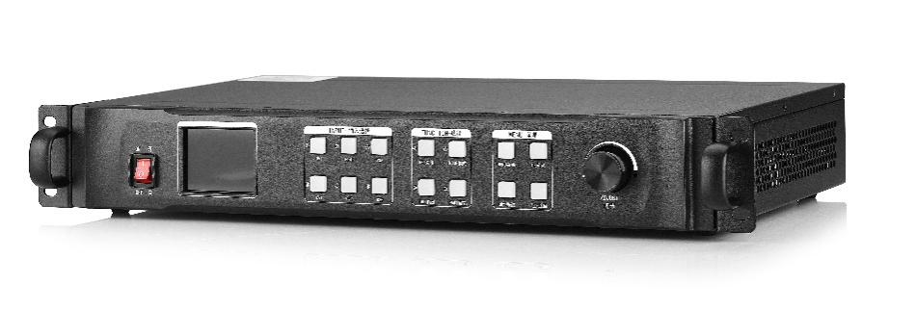
Functional characteristics
- 2 channel programming output channel, the most wide band of 1920 pixels, with a maximum load of 1200 pixels.
- Any part of the signal source is intercepted and displayed.
- Support multiple high definition signal inputs
- Executable offline planning tasks
- can save 5 scene modes, one key call.
- Support direct cut and fade in, no black screen, Caton.
- Panel recognition source status
- Support one button black screen / stati.
- Support PC software control.
- Support brightness 0-255 adjustment
- Two LED sending cards can be built.

Panel description
Serial number | Functional description
① | Power switch
② | Full color LCD information screen
③ | Signal source quick select area
④ | Function button area
⑤ | Parameter setting and debugging area
⑥ | Knob adjustment

Port specification
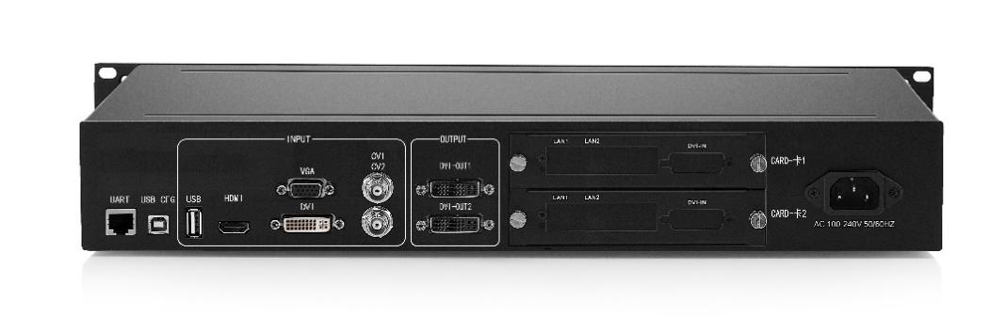

Input port
type | Number | Specifications
CVBS（BNC） | 2 | NTSC/PAL adaptive, 3D comb filter support
VGA | 1 | VESA standard, maximum support 1920 * 1080@60Hz
DVI | 1 | The maximum support is 1920 x 1200@60Hz, compatible with HDMI1.3 and the following versions.
HDMI | 1 | Compatible with HDMI1.3 and below
USB | 1 | USB2.0, support USBoffline play.
Audio | 4 | 3.5 mm port

Output port
type | Number | Specifications
DVI-D | 2 | Maximum horizontal resolution 1920 pixels  Vertical resolution up to 1200 pixels
Audio | 1 | 3.5 mm port

Control port
type | Number |  | Specifications
USB-CFG | 1 |  | USB Type B
UART（RJ-45） | 1 |  | IN&OUT, serial port protocol
Complete machine specification
Input power supply |  | 100-240V AC~50/60Hz 0.6A
working temperature |  | 0-45℃
Shape size |  | 483×283×72mm（L×W×H）
Net weight |  | 4KG
Complete machine power consumption |  | 36W

Appendix: equipment size drawing
Front size map

Back size drawing

Side size map

